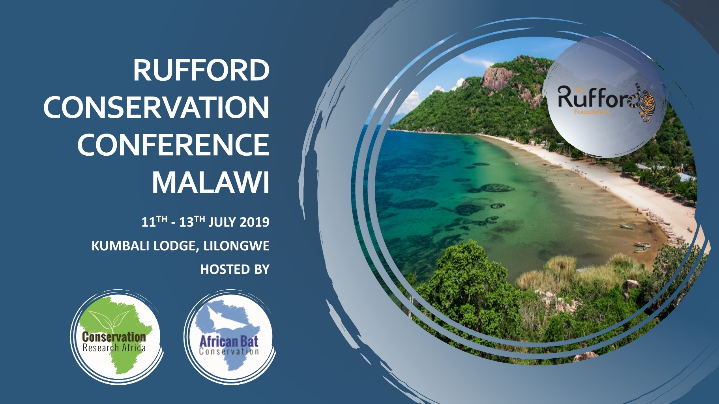

Abstract Submission Form

Abstract Guidelines
- All abstracts must be written in English.
- It is the author's responsibility to submit a correct abstract. Any errors in spelling, grammar or scientific fact will be reproduced as submitted by the author.
- The text cannot exceed 300 Words.
- No graphics will be permitted.
- Authors who wish to submit more than one abstract should fill out a separate submission form for each abstract.
- All abstracts will be reviewed and the final selection made by the Scientific Committee (“SC”).
- No accepted abstract will be included in the programme unless registration and payment has been received.
- All accepted presenters must be registered and fully paid by 31st April 2019.
- Notification of acceptance will commence week of 6th May 2019.

Choose your presentation type preference below.

Oral
Individual oral presentations allow for a brief overview of the major points / highlights of a particular project or programme. Oral presentations are limited to 20 minutes with 5 minutes for questions. Oral abstracts are not to exceed 300 words.

Poster
Material for a display presentation is mounted on a poster board (A1), which is staffed by the author (this is mandatory) for a designated period of time. This format provides a unique opportunity for personal 'one-on-one' interaction and idea exchange. Poster abstracts are not to exceed 300 words.

Abstracts are to be informational and report on work completed. Abstracts based on preliminary results may be considered depending on space availability.

Are you submitting an abstract for a poster or oral presentation or both?

Oral Presentation: ☐

Poster: ☐

Authors (please list all authors including full names and institutional affiliations, addresses and email contacts):

Title of talk/poster (maximum 20 words):

Abstract Theme: The themes are the general heading under which abstracts will be submitted and reviewed. (Please select the most appropriate category and mark an x in the box for those that apply).

1. Applied Research
2. Community education and capacity building
3. Advances in conservation management
4. Conservation genetics
14. Other (please indicate in the body of your abstract the theme your presentation would suit)

Abstract Format

One paragraph should include ALL of the following sections, in no more than 300 words.

- What conservation problem or question does your talk/poster address?
- What were the main research methods you used?
- What are your most important results?
- What is the relevance of your results to conservation?

Evaluation process
Criteria for evaluating the quality of abstracts include originality of ideas and methods, concise presentation of methods and results, clarity of application and implementation and quality of writing.
Two reviewers will assess each abstract.

Submission
Please email this completed form to ruffordconferencemalawi@conservationresearchafrica.org no later than 31st April 2019.

